Table of Content
SEMESTER PROJECT: CLOUD-BASED LIBRARY MANAGEMENT SYSTEM 4
1. PROJECT PROPOSAL, EXECUTIVE SUMMARY & PROBLEM DEFINITION 4
1.1 Executive Summary 4
1.2 Introduction 4
1.3 Problem Statement 4
1.4 Aim & Objectives 4-5
2. AWS ARCHITECTURE DESIGN & IMPLEMENTATION 5
2.1 AWS Architecture Description 6
2.2 Implementation Steps 6-7
2.3 Security & IAM 7
3. SCREENSHOOTS OF THE IMPLEMENTATION 8-34
PHASE 1: LAB ENVIRONMENT & AUTHENTICATION 8
PHASE 2: NETWORK INFRASTRUCTURE (VPC) 9
PHASE 3: SECURITY & ACCESS CONTROL 16
PHASE 4: DATABASE DEPLOYMENT (RDS) 18
PHASE 5: OBJECT STORAGE 20
PHASE 6: CONTAINER REGISTRY (ECR) 23
PHASE 7: LOAD BALANCING (ALB) 24
PHASE 8: ORCHESTRATION (ECS) 26
PHASE 9: FINAL APPLICATION OUTPUT 27
PHASE 10: MONITORING & OBSERVABILITY 32
3. REFERENCES 34

Table of Figures
SEMESTER PROJECT: CLOUD-BASED LIBRARY MANAGEMENT SYSTEM 4
Figure 1: AWS Architecture 5
Figure 2: AWS Learner Lab Details Panel 8
Figure 3: AWS CLI Credentials Configuration 8
Figure 4–6: Cloud9 IDE Workspace 9-10
Figure 7–8: Custom VPC Dashboard 11
Figure 9: VPC Resource Map 12
Figure 10–11: Subnet Configuration 13
Figure 12–14: Internet Gateway Attachment 14-15
Figure 15–16: Route Table Configuration 15-16
Figure 17: Security Groups Overview 16
Figure 18–19: App / ALB Security Group Rules 17
Figure 20: Database Security Group Rules 18
Figure 21: RDS Dashboard 18
Figure 22: Database Instance Class & RDS Connectivity Endpoint 19
Figure 23: Subnet Group Configuration 20
Figure 24: S3 Bucket Overview 20
Figure 25-27: Uploaded Objects Preview 22
Figure 28: Docker Build Output 23
Figure 29: ECR Repositories List 23
Figure 30: ECR Image Details 24
Figure 31–32: Load Balancer Dashboard 24-25
Figure 33: Target Group Configuration & Target Health Check 25
Figure 34–35: ECS Cluster Status, Service Deployment & Event Logs 26
Figure 36: Task Definition Blueprint 27
Figure 37–45: Frontend Application Output 28-34
Figure 46-48: CloudWatch RDS Performance and CPU Utilization 33

SEMESTER PROJECT: CLOUD-BASED LIBRARY MANAGEMENT SYSTEM

1. PROJECT PROPOSAL, EXECUTIVE SUMMARY & PROBLEM DEFINITION

1.1 Executive Summary
This project outlines the design and deployment of a scalable, cloud-native Library Management System (LMS) on Amazon Web Services (AWS). Traditional local LMS solutions suffer from limited accessibility, poor scalability, and risk of data loss. This solution leverages AWS containerization (ECS & ECR), managed databases (RDS), and secure networking (VPC) to create a robust application. The project successfully demonstrates the migration of a local application to a cloud environment, ensuring high availability and automated infrastructure management within the constraints of the AWS Learner Lab environment.
DNS Link: library-alb-1340845113.us-east-1.elb.amazonaws.com

1.2 Introduction
The Library Management System is a critical tool for educational institutions, managing the circulation of books, member records, and inventory. As institutions grow, on-premise servers fail to handle increased traffic and data loads. This project migrates a modern LMS codebase to AWS, utilizing Cloud9 for development, Elastic Container Service (ECS) for orchestration, and Relational Database Service (RDS) for persistent storage.

1.3 Problem Statement
Most libraries rely on legacy, on-premise software that requires expensive hardware maintenance and lacks remote accessibility.
- Scalability: Physical servers cannot handle sudden spikes in user traffic during exam periods.
- Data Integrity: Local backups are prone to corruption and hardware failure.
- Accessibility: Users cannot access the catalog or renew books remotely without complex VPNs.

1.4 Aim & Objectives
Aim: To deploy a fully functional, containerized Library Management System on AWS that ensures high availability and secure data management.
Objectives:
- Network Design: Implement a custom Virtual Private Cloud (VPC) with public/private subnets and internet gateways.
- Containerization: Dockerize the LMS application and store images securely in Amazon Elastic Container Registry (ECR).
- Object Storage: Implement Amazon S3 to offload static assets (User Profiles, Book Covers) from the container, ensuring stateless application design.
- Orchestration: Deploy the application using Amazon ECS with Target Groups for traffic distribution.
- Database Management: Utilize Amazon RDS for a managed, reliable SQL database backend.
- Security: Implement network security via Security Groups and utilize the restricted LabRole for service authorization.
- Observability: Configure Amazon CloudWatch to monitor container health, CPU utilization, and application logs in real-time.

2. AWS ARCHITECTURE DESIGN & IMPLEMENTATION

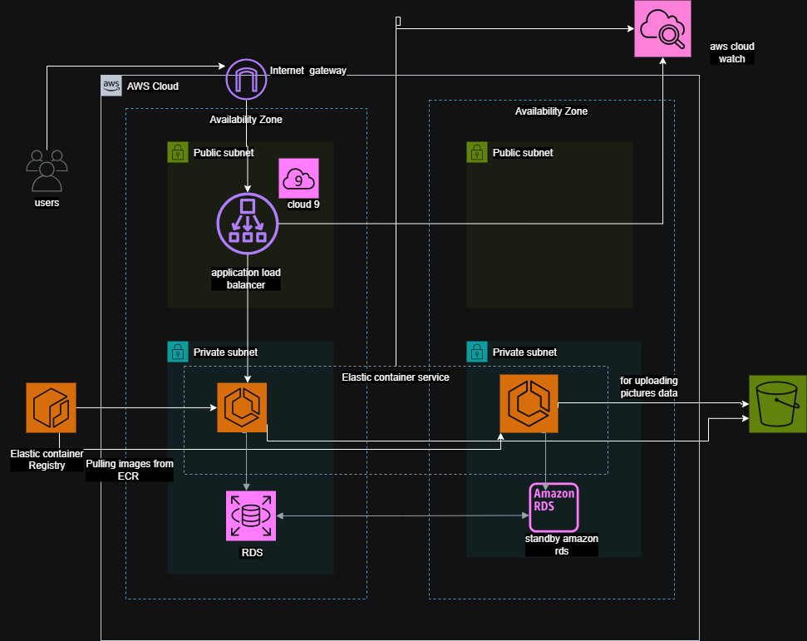
Figure 1: AWS Architecture

2.1 AWS Architecture Description
The architecture follows a multi-tier microservices pattern:
- Network Layer: A VPC hosting two subnets. A Public Subnet contains the Internet Gateway and Application Load Balancer (ALB) / Target Groups.
- Compute Layer: Amazon ECS (Elastic Container Service) runs the LMS Docker containers. Cloud9 is used as the development environment (IDE) to build and push images.
- Storage Layer:
- Relational: Amazon RDS (MySQL) resides in the private network scope to store relational data (book/user records).
- Object: Amazon S3 is used to store unstructured data such as book cover images and user profile pictures, reducing the storage burden on the application container.
- Security Layer: Security groups act as virtual firewalls. IAM access is managed via the pre-defined LabRole.
- Monitoring Layer: Amazon CloudWatch aggregates logs from ECS tasks and tracks performance metrics (CPU/Memory usage) to ensure system reliability.

2.2 Implementation Steps

Phase 1: Network Setup (VPC)
- VPC Creation: Created a custom VPC (MERN-Project-VPC) in the us-east-1 region.
- Subnets & Route Tables:
  - Created Public Subnets for internet access.
  - Created an Internet Gateway (IGW) and attached it to the VPC to allow outbound traffic.
  - Configured Route Tables to direct traffic 0.0.0.0/0 to the IGW.

Phase 2: Database Setup (RDS)
- Service Selection: Navigated to RDS console.
- Configuration: Launched a db.t3.micro instance (Burstable class) to stay within Learner Lab budget limits.
- Security: Configured the security group to allow inbound traffic on port 3306 (MySQL) or 5432 (PostgreSQL) only from the ECS tasks/Security Group.
  - Constraint Note: Enhanced monitoring was disabled as per lab restrictions.

Phase 3: Object Storage Setup (S3)
- Bucket Creation: Created a unique S3 bucket (e.g., lms-static-assets) in the us-east-1 region.
- Permissions:
  - Disabled "Block All Public Access" (or configured specific ACLs) to allow the application to retrieve images.
  - Configured Cross-Origin Resource Sharing (CORS) to allow the web frontend to fetch images directly from the bucket.
- Integration: Updated the app.py configuration to include AWS_S3_BUCKET_NAME and S3_REGION environment variables.

Phase 4: Development & Container Registry (Cloud9 & ECR)
- Environment: Launched an AWS Cloud9 environment to access the CLI and git.
- Source Control: Cloned the repository: git clone https://github.com/BSSE-23050/LMS.git.
- Docker Build: Used the terminal to build the docker image.
  - Command: docker build -t lms-app .
- ECR Repository: Created a private repository in Amazon ECR.
- Push to ECR: Authenticated Docker with AWS CLI and pushed the image to the repository.

Phase 5: Deployment (ECS & Target Groups)
- Target Group: Created a Target Group (library-tg2) to route HTTP traffic (Port 80) to the container port.
- Task Definition: Created a Task Definition using the ECR Image URI.
  - IAM Role Configuration: Assigned the LabRole as the "Task Role" and "Task Execution Role" because the Learner Lab restricts creating new IAM roles.
- Service Creation: Deployed an ECS Service with the defined task, mapped to the Target Group.
- Log Configuration: configured the Task Definition to use the awslogs driver, automatically streaming all container stdout/stderr output to Amazon CloudWatch Logs.

2.3 Security & IAM
Challenge: The AWS Learner Lab environment has strict restrictions on IAM. Users "cannot create roles, except... service-linked roles". Solution:
- Role Usage: We utilized the pre-existing LabRole. This role is designed to be attached to EC2, Lambda, or ECS tasks and grants necessary permissions for services to interact.
- Credentials: For CLI access within the lab (or local development), we utilized the temporary AWS Access Keys (aws_access_key_id, aws_secret_access_key, and aws_session_token) provided by the "AWS Details" panel in the lab interface. These tokens change every session.
- Network Security: Security Groups were configured to ensure the RDS database is not publicly accessible, only accepting connections from the application layer.

3. SCREENSHOOTS OF THE IMPLEMENTATION

PHASE 1: LAB ENVIRONMENT & AUTHENTICATION

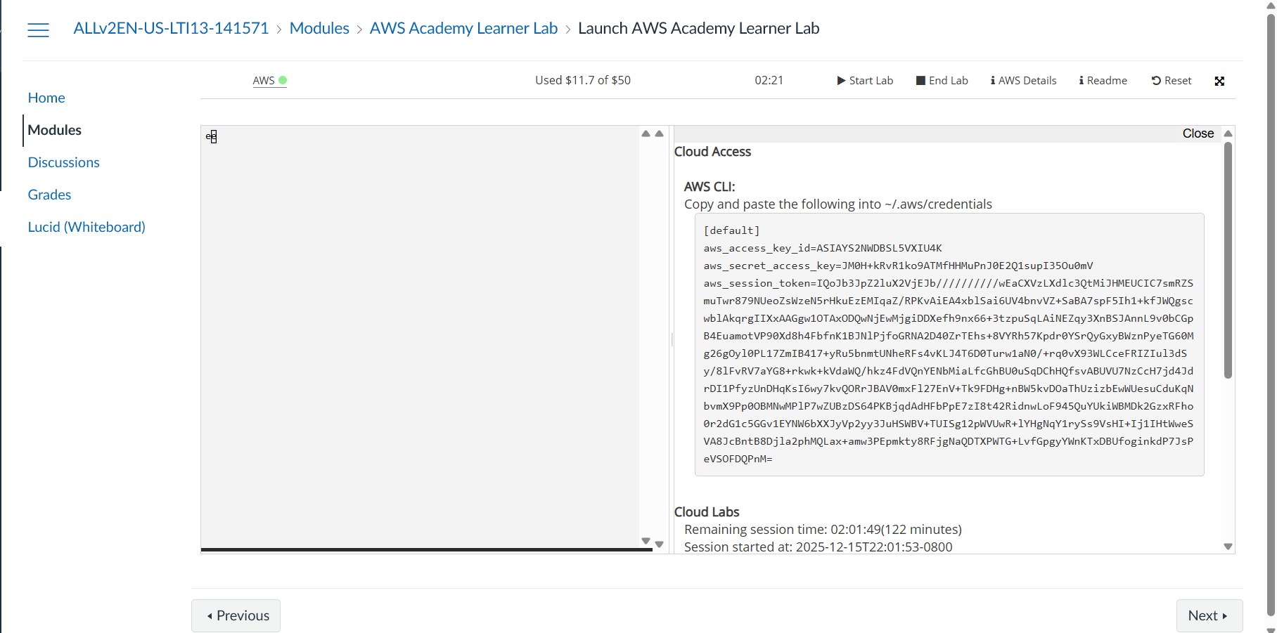
Figure 2: AWS Learner Lab Details Panel
- Description: The starting point of the lab environment. This panel provides the temporary AWS Access Key, Secret Key, and Session Token required for programmatic access to AWS services.
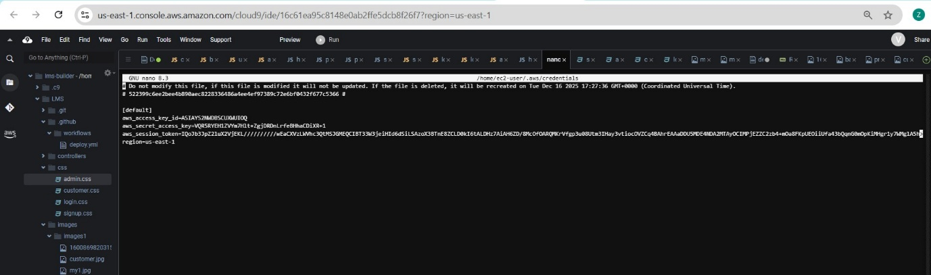
Figure 3: AWS CLI Credentials Configuration
- Description: The ~/.aws/credentials file inside the Cloud9 environment. This screenshot demonstrates the manual injection of session tokens to authenticate the AWS CLI, bypassing the restriction on creating new IAM execution roles.
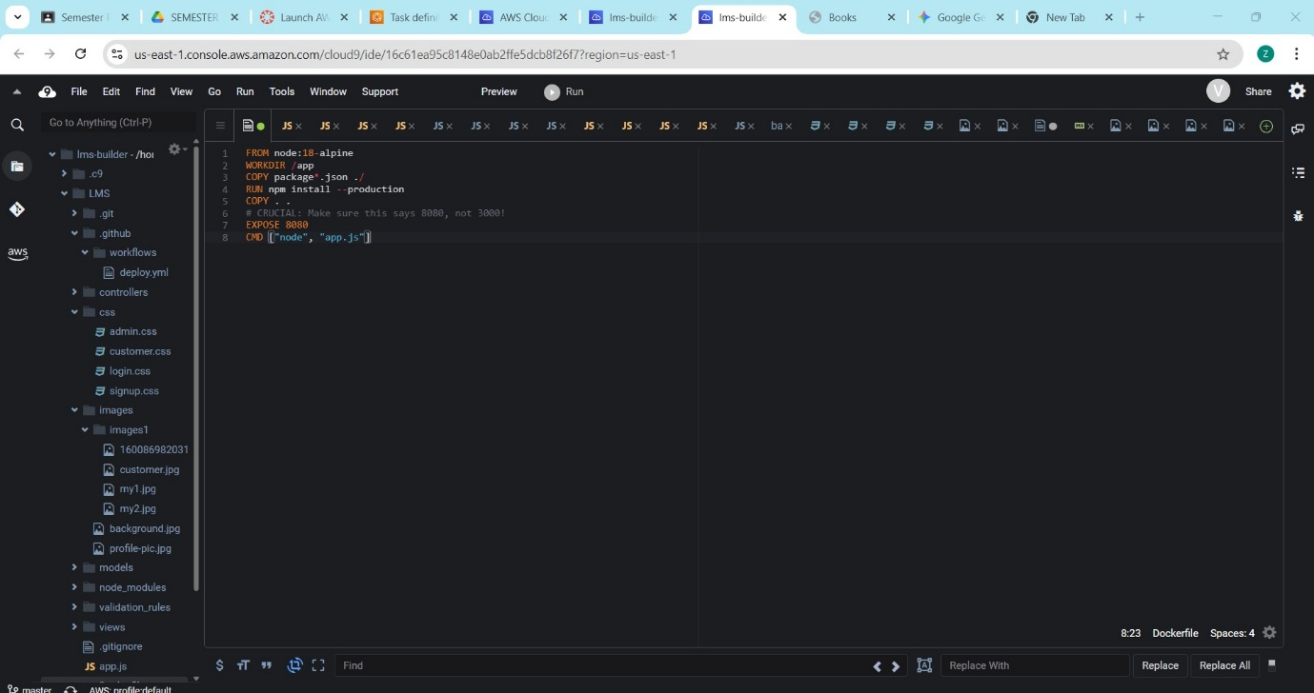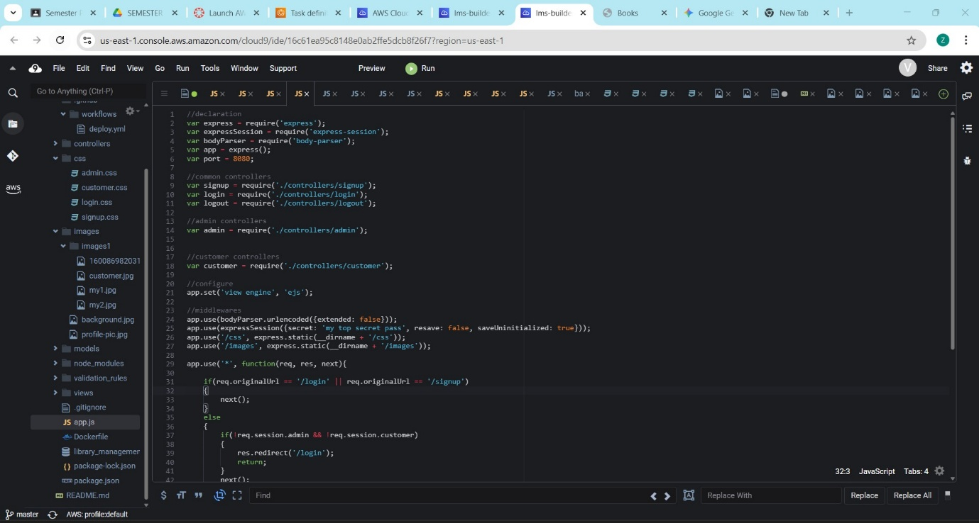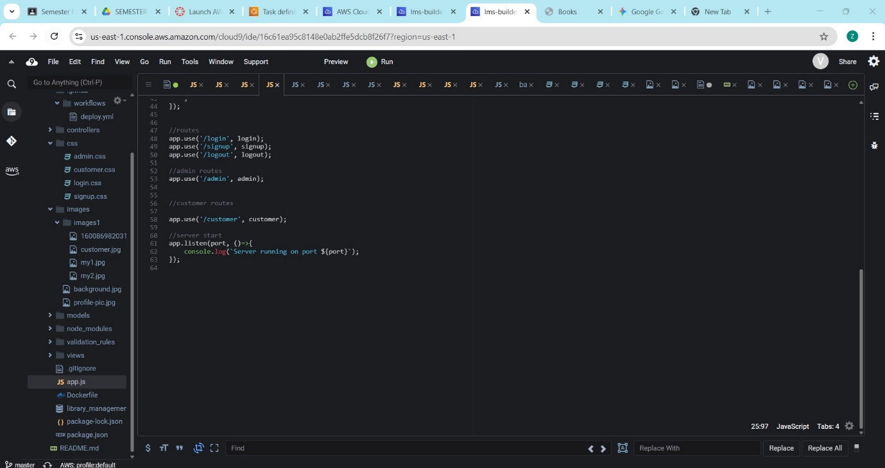
Figure 4, 5, 6: Cloud9 IDE Workspace
- Description: The active AWS Cloud9 development environment. The file tree displays the project structure, including app.py, and the Dockerfile, confirming the code is present in the cloud environment.

PHASE 2: NETWORK INFRASTRUCTURE (VPC)

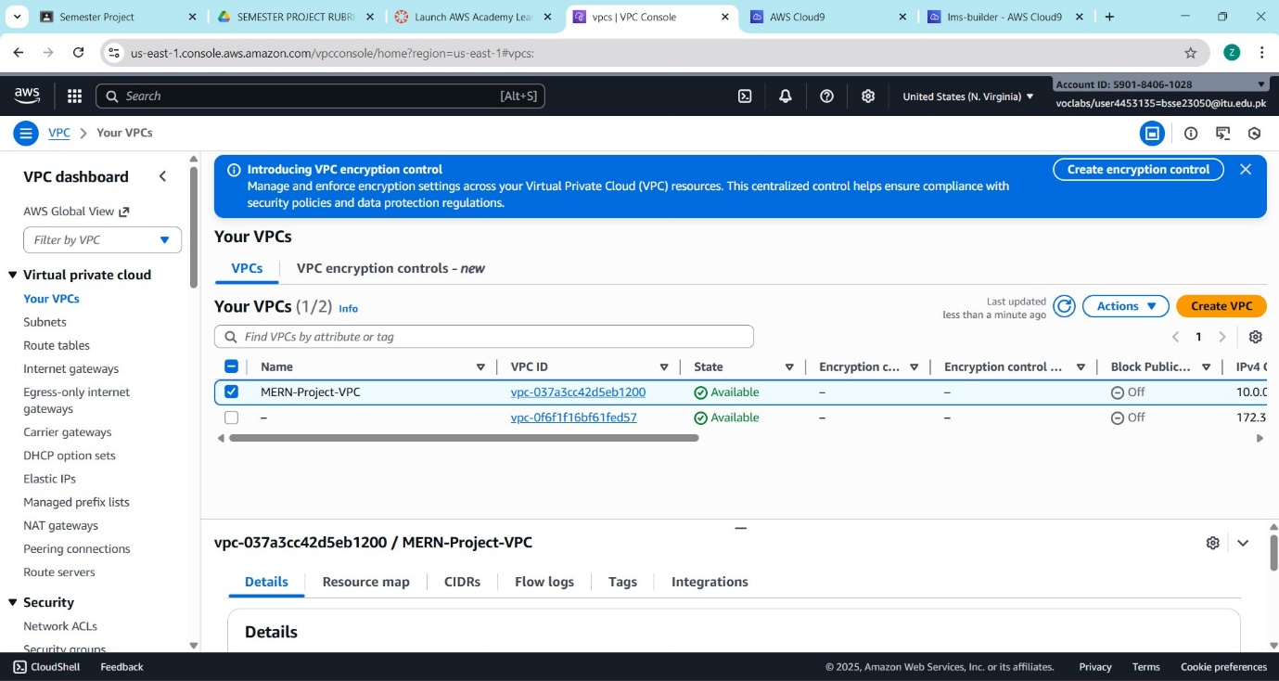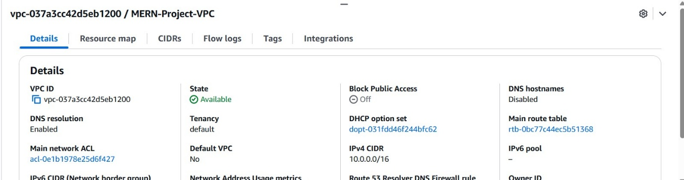
Figure 7, 8: Custom VPC Dashboard
- Description: The VPC console listing the custom MERN-Project-VPC. It shows the allocated IPv4 CIDR block (10.0.0.0/16), confirming the creation of an isolated network space for the project.
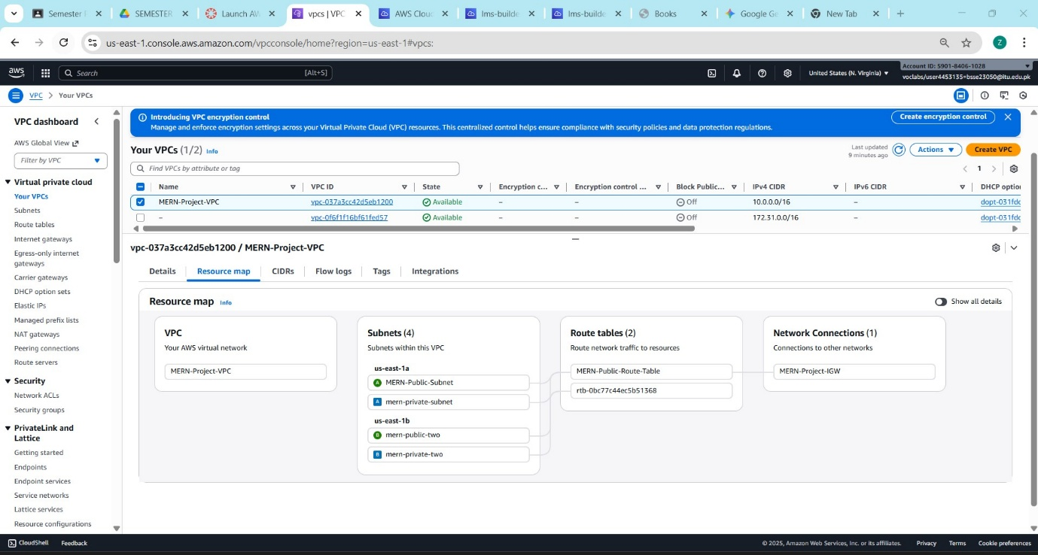
Figure 9: VPC Resource Map
- Description: A topology diagram generated by AWS. It visually maps the connections between the MERN-Project-VPC, its Subnets, Route Tables, and the Internet Gateway, providing a high-level architectural view.
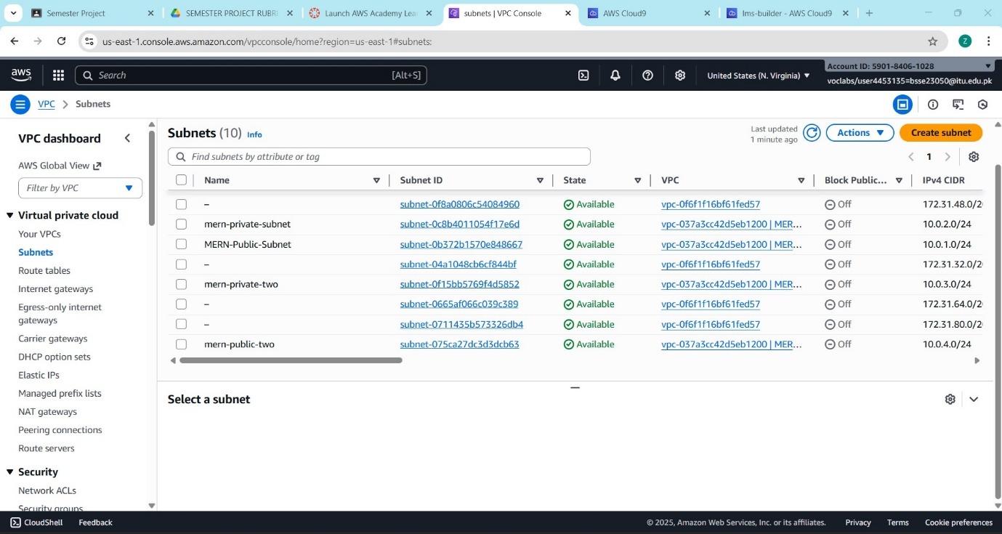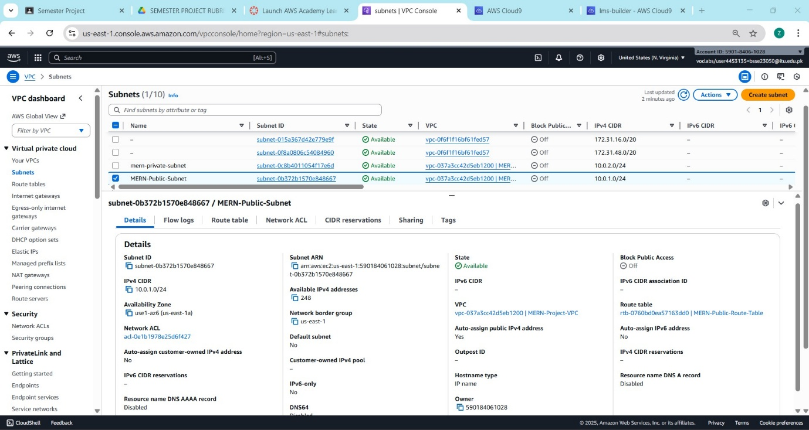
Figure 10, 11: Subnet Configuration
- Description: The list of subnets created within the VPC. It distinguishes between the Public Subnet (for the Load Balancer) and the Private Subnet (for the Database), adhering to security best practices.
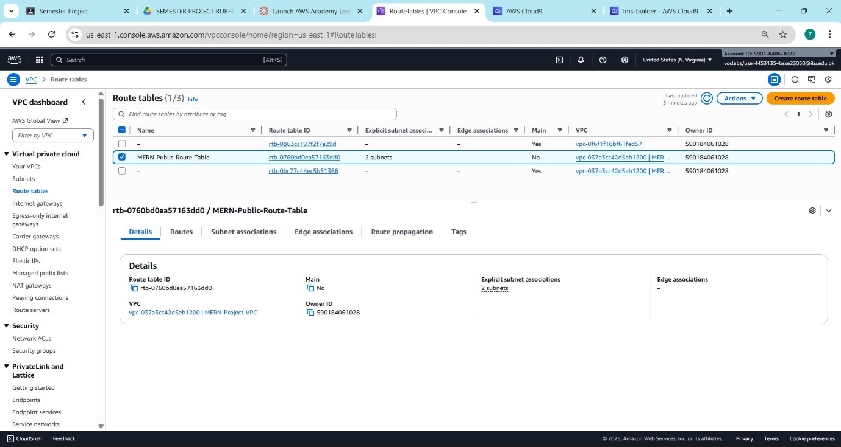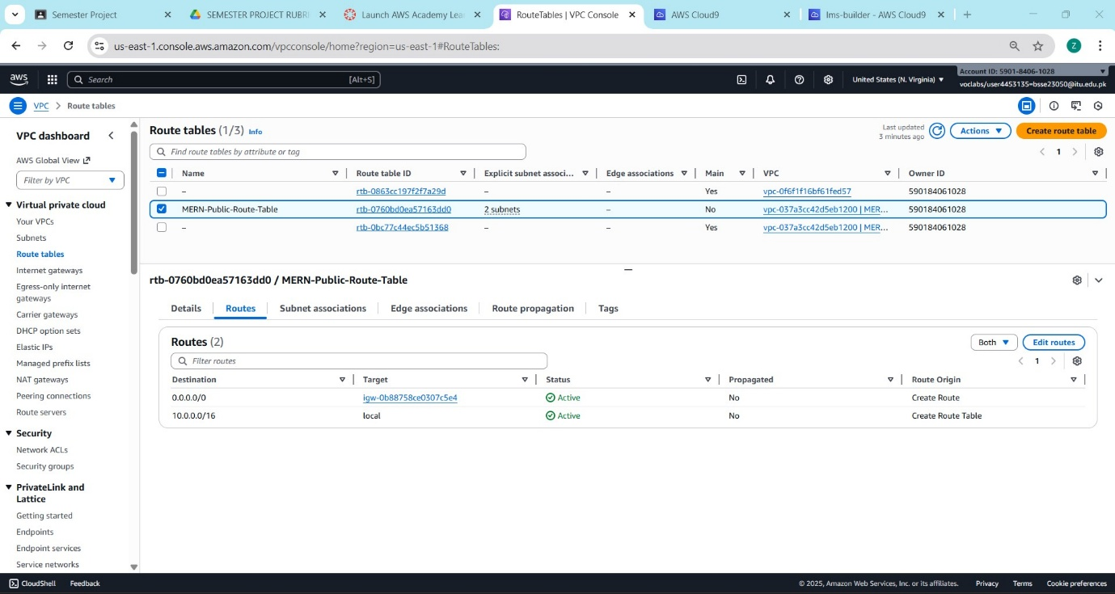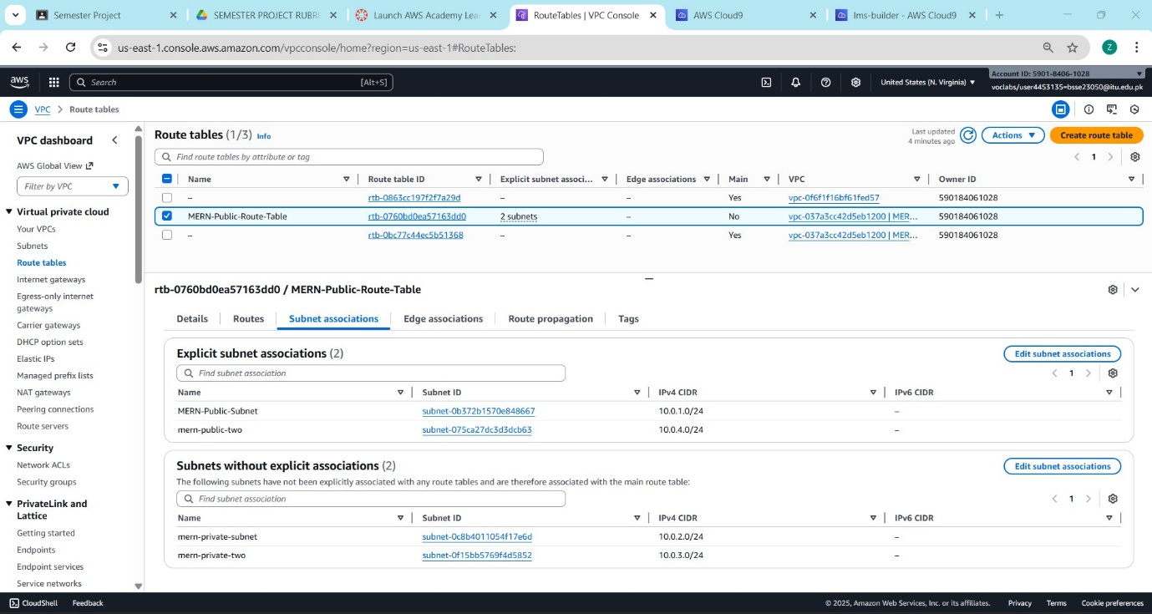
Figure 12, 13, 14: Internet Gateway Attachment
- Description: The Internet Gateway (IGW) attached to the VPC. This component is essential for allowing the application containers in the public subnet to communicate with the external internet.


Figure 15, 16: Route Table Configuration
- Description: The Route Table associated with the public subnet. The entry 0.0.0.0/0 -> igw-xxxx confirms that internet-bound traffic is correctly routed through the gateway.

PHASE 3: SECURITY & ACCESS CONTROL

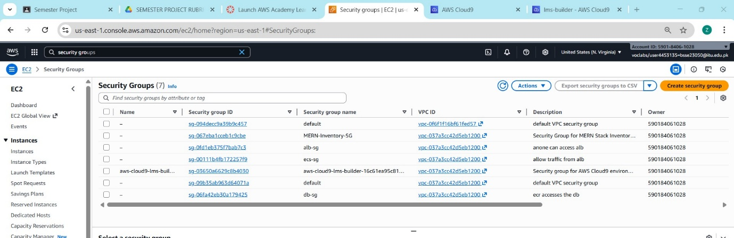
Figure 17: Security Groups Overview
- Description: The list of Security Groups created for the project. It shows distinct groups for the Load Balancer, the Application (ECS), and the Database (RDS), ensuring granular control over traffic.
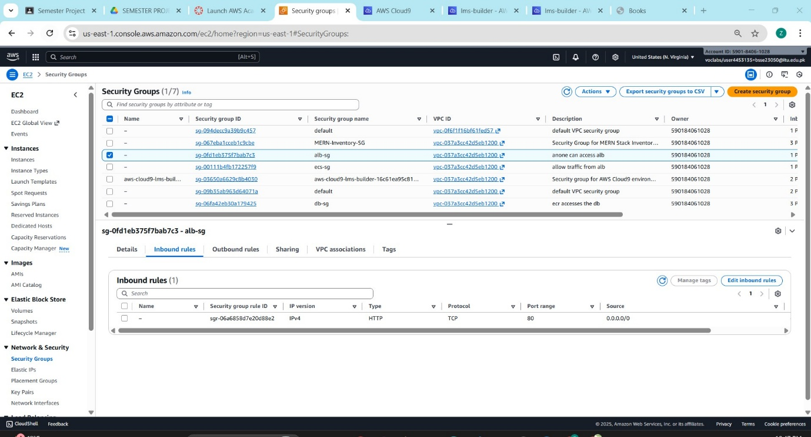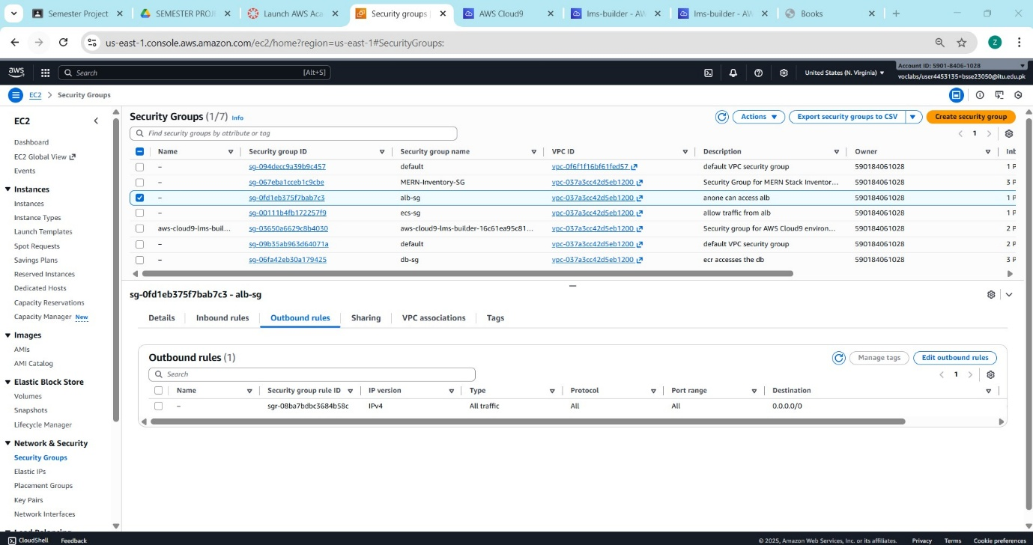
Figure 18, 19: App/ALB Security Group Rules
- Description: The Inbound Rules for the Application Security Group. It shows that HTTP traffic (Port 80) is allowed from the internet, enabling user access to the website.
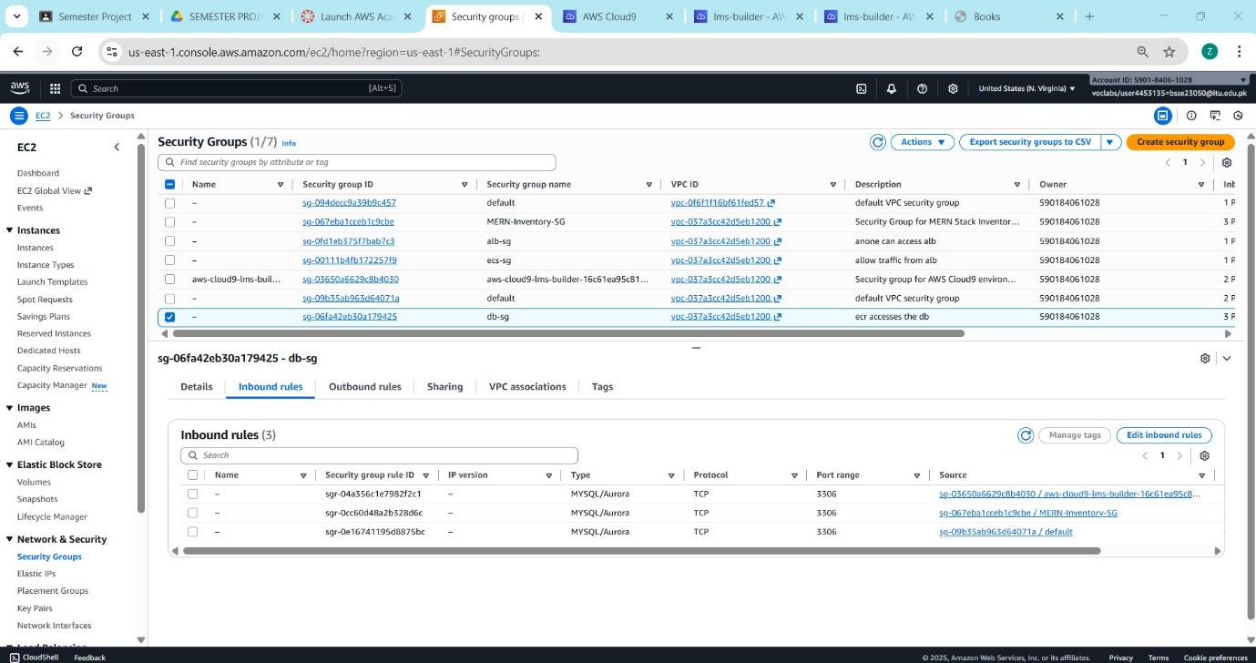
Figure 20: Database Security Group Rules
- Description: The restricted Inbound Rules for the RDS Security Group. It demonstrates that traffic on Port 3306 (MySQL) is only allowed from the Application Security Group ID, preventing public access to the data.

PHASE 4: DATABASE DEPLOYMENT (RDS)

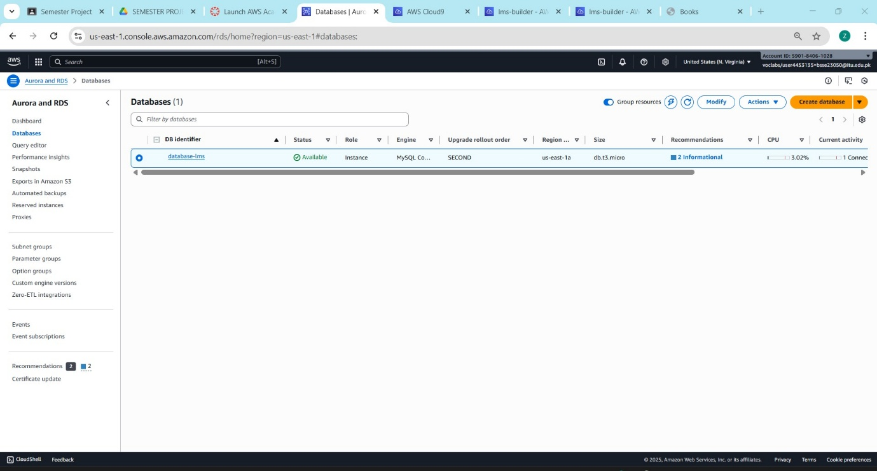
Figure 21: RDS Dashboard
- Description: The Amazon RDS console showing the database-lms instance. The status is "Available", confirming the database is successfully provisioned.
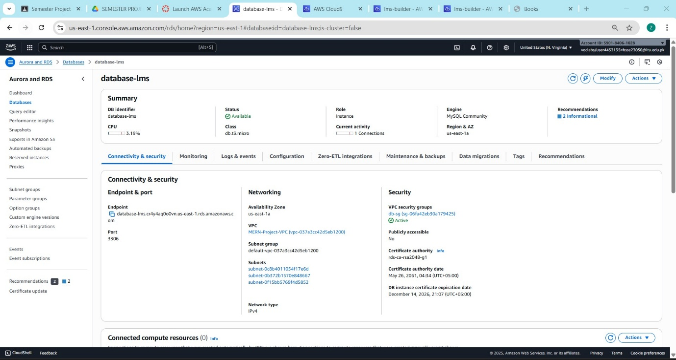
Figure 22: Database Instance Class & RDS Connectivity Endpoint
- Description: The configuration details of the RDS instance. It highlights the use of the db.t3.micro class and "Free Tier" settings to optimize costs within the Learner Lab budget.
- Description: The specific Endpoint URL and Port number provided by AWS. This string is used by the application code to establish the connection to the managed database.

Figure 23: Subnet Group Configuration
- Description: The DB Subnet Group details. It confirms that the database is deployed across multiple Availability Zones (AZs) within the private subnets for higher reliability.

PHASE 5: OBJECT STORAGE

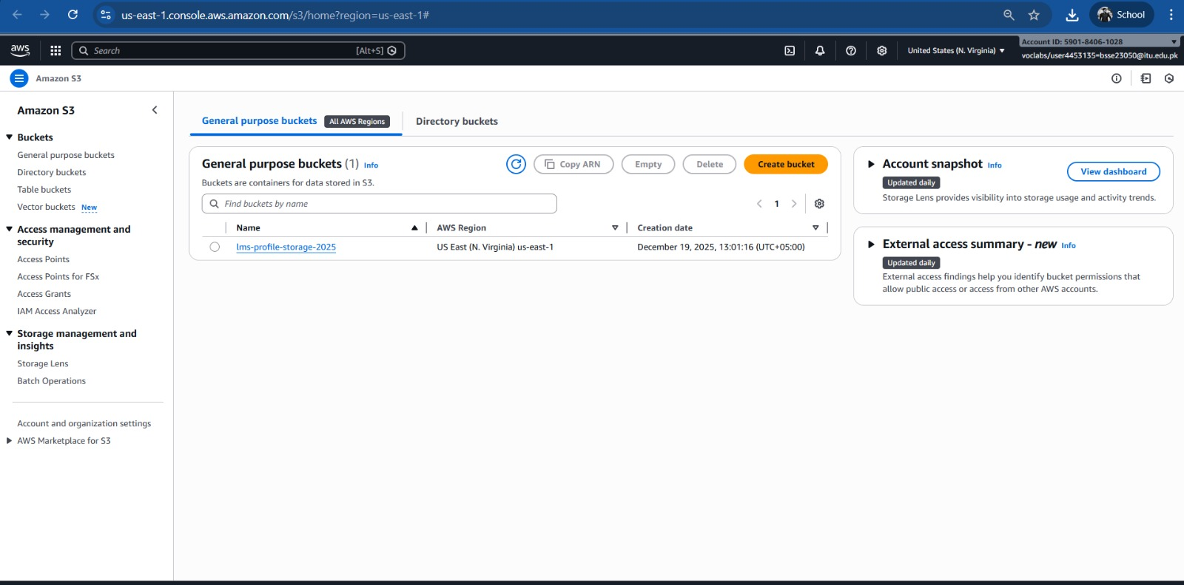
Figure 24: S3 Bucket Overview
- Description: The Amazon S3 console displaying the created bucket lms-assets-bucket. This bucket acts as the centralized repository for all static media files (profile pictures and admin dps), decoupling storage from the application compute layer.
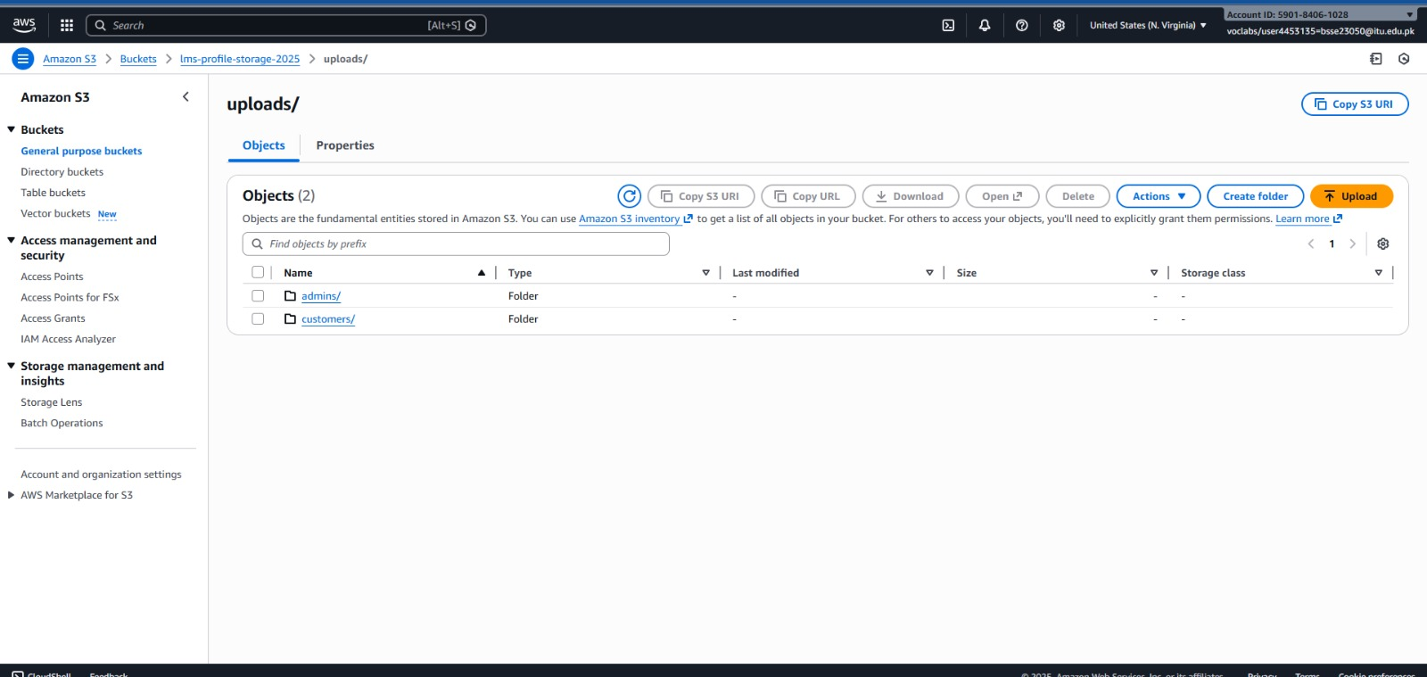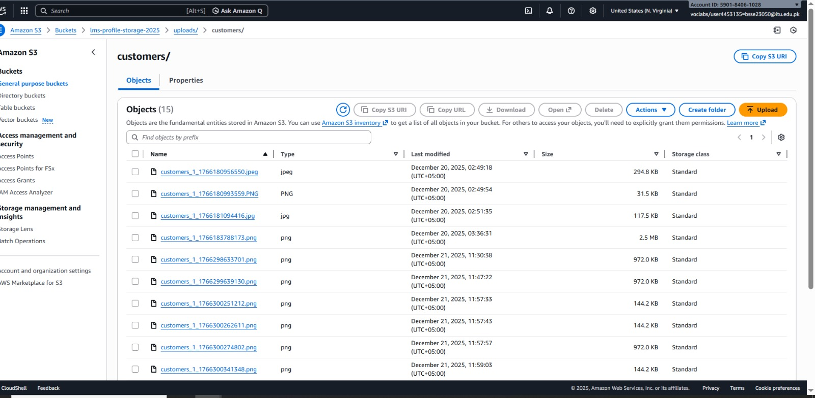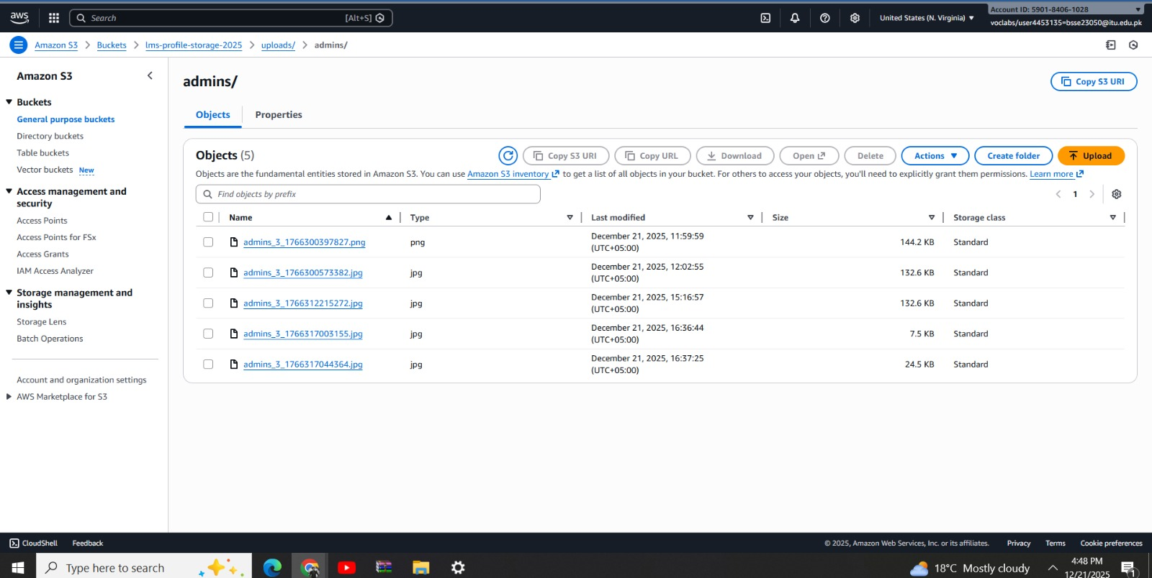
Figure 25,26,27: Uploaded Objects Preview
- Description: A view inside the S3 bucket showing successfully uploaded image files (e.g., .jpg, .png). This validates that the application's "Image Upload" feature is correctly communicating with the S3 API.

PHASE 6: CONTAINER REGISTRY (ECR)

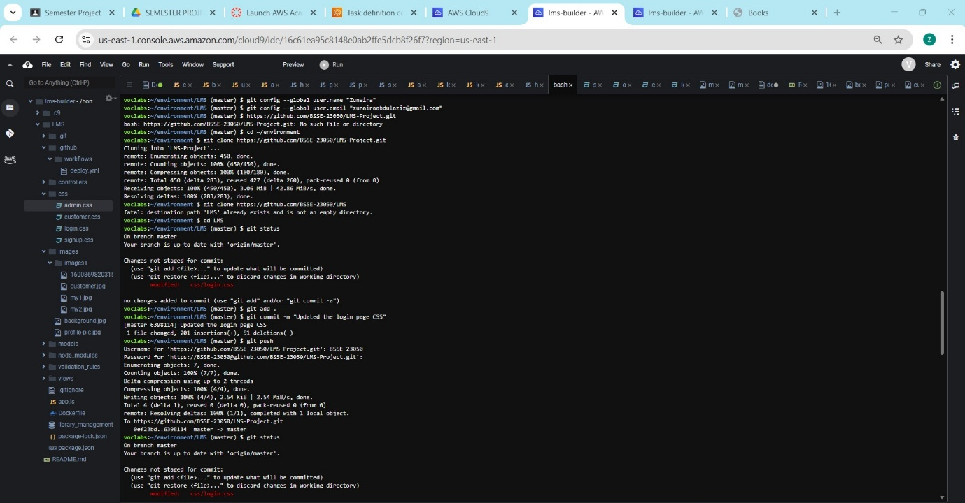
Figure 28: Docker Build Output
- Description: The terminal output in Cloud9 showing the successful execution of docker build -t lms-app . This proves the application code was successfully containerized.
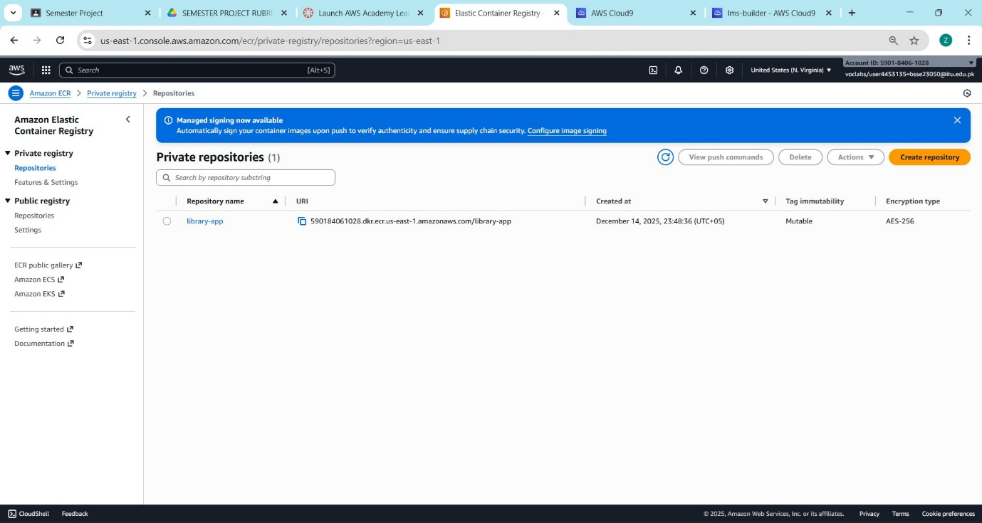
Figure 29: ECR Repositories List
- Description: The Amazon ECR console showing the creation of the private repository lms-project.
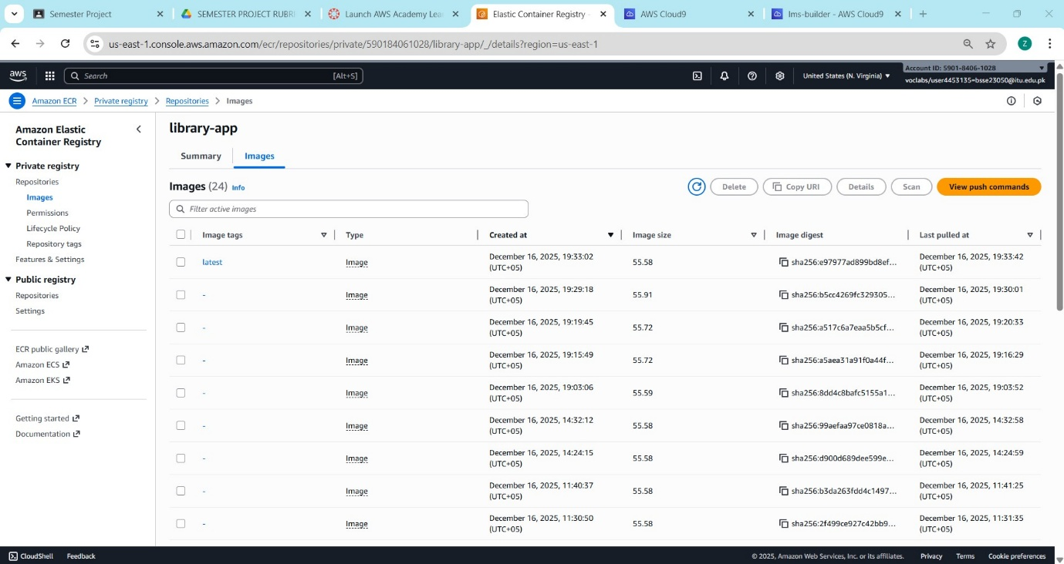
Figure 30: ECR Image Details
- Description: The repository contents showing the pushed image. The tag "latest" and the "Image URI" confirm that the Docker image is stored securely and ready for deployment.

PHASE 7: LOAD BALANCING (ALB)

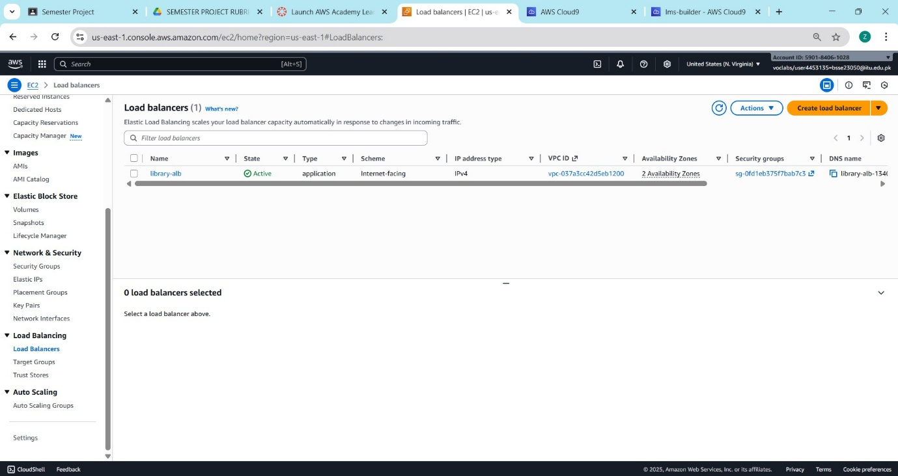

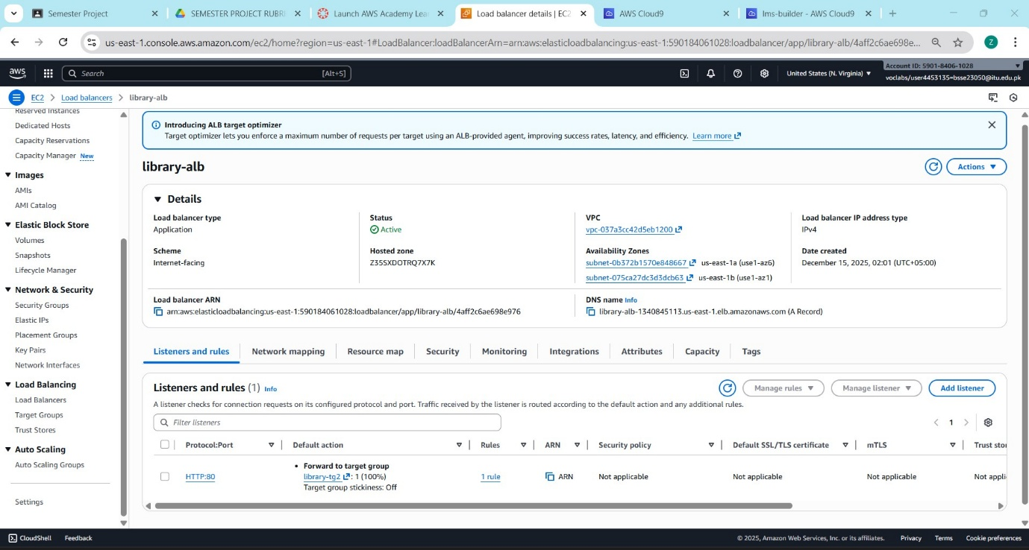
Figure 31, 32: Load Balancer Dashboard
- Description: The EC2 Load Balancer console showing the Application Load Balancer (ALB) in the "Active" state. It displays the DNS name used to access the website.
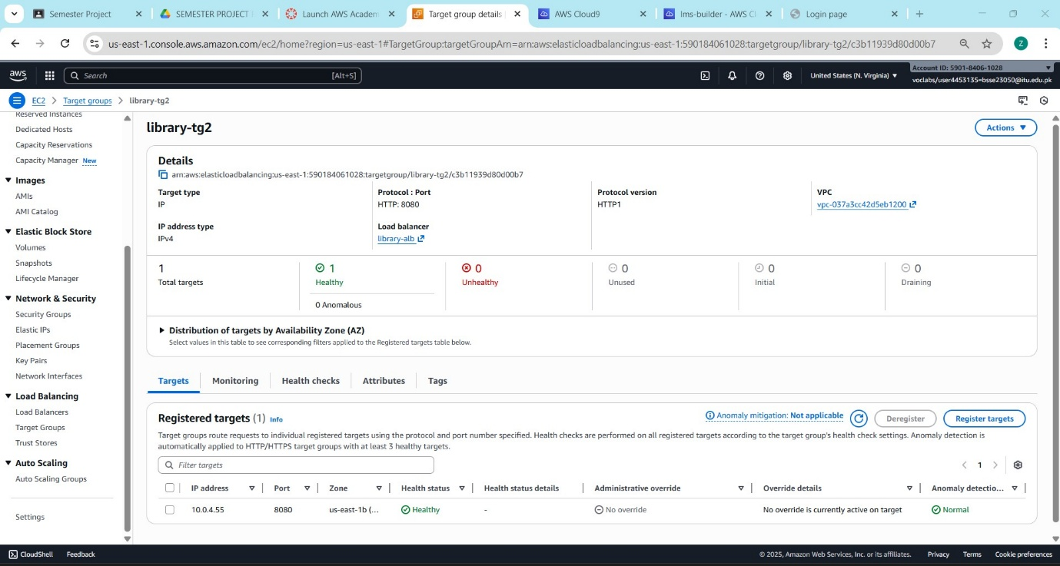
Figure 33: Target Group Configuration & Target Health Check
- Description: The Target Group settings. It shows the protocol is HTTP on Port 80 and the target type is "IP", which is required for AWS Fargate tasks.
- Description: The "Targets" tab within the Target Group. The status "Healthy" confirms the ALB can successfully reach the ECS container and receive a valid response.

PHASE 8: ORCHESTRATION (ECS)

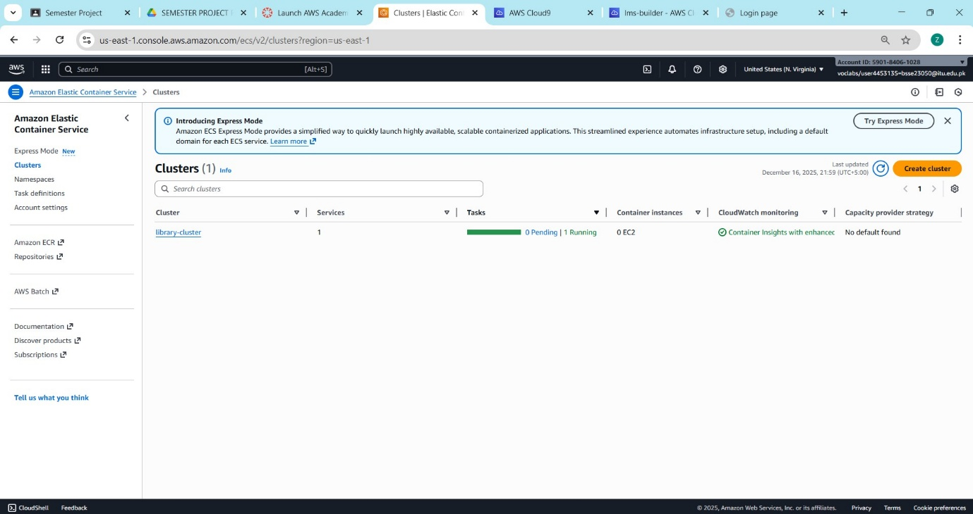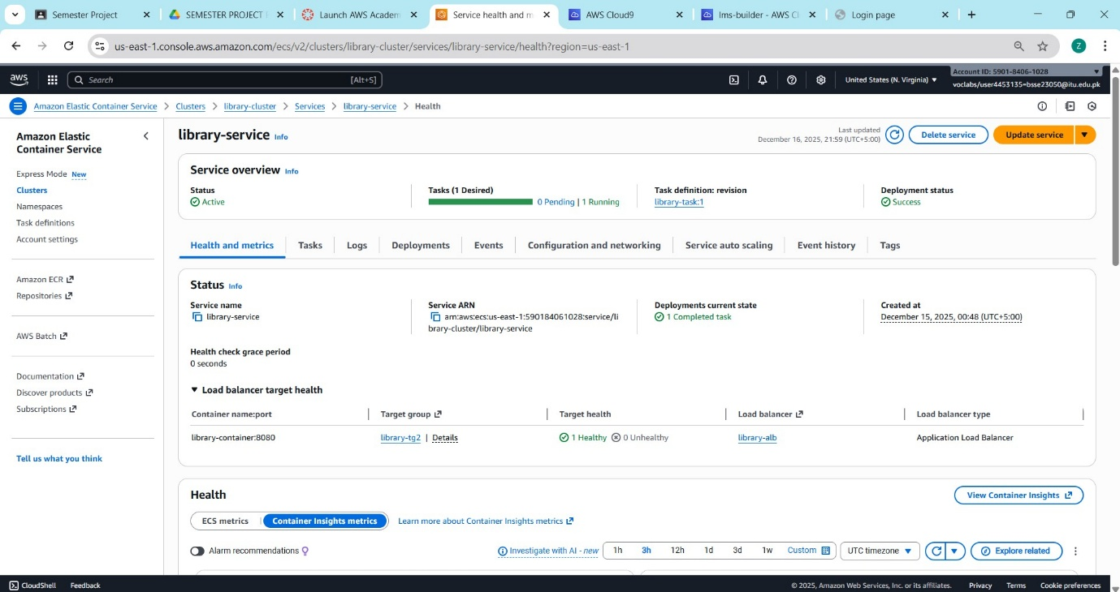
Figure 34, 35: ECS Cluster Status & ECS Service Deployment & Service Event Log
- Description: The ECS Cluster dashboard showing the status "Active". This cluster serves as the management boundary for the application services.
- Description: The ECS Service status showing "Running tasks: 1". This confirms the orchestrator has successfully launched the container based on the task definition.
- Description: The "Events" tab in the ECS Service. The log "service has reached a steady state" serves as proof of a stable and successful deployment.
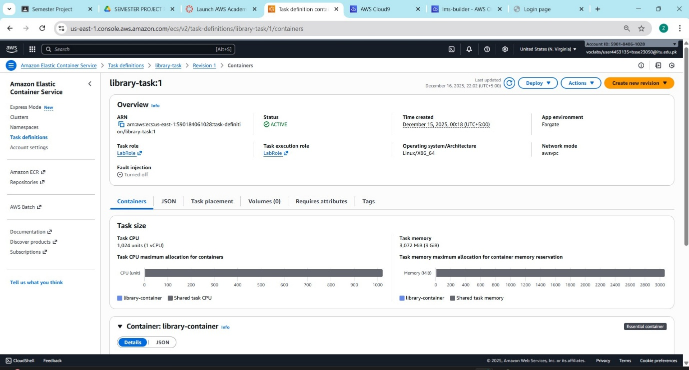
Figure 36: Task Definition Blueprint
- Description: The Task Definition details. It shows the container definitions, including the image mapping and the environment variables (DB_HOST, DB_USER) passed to the container.

PHASE 9: FINAL APPLICATION OUTPUT

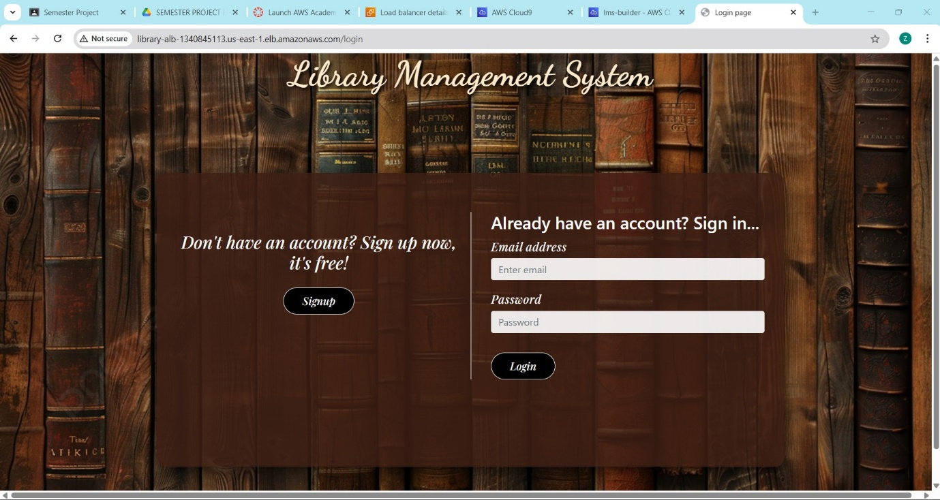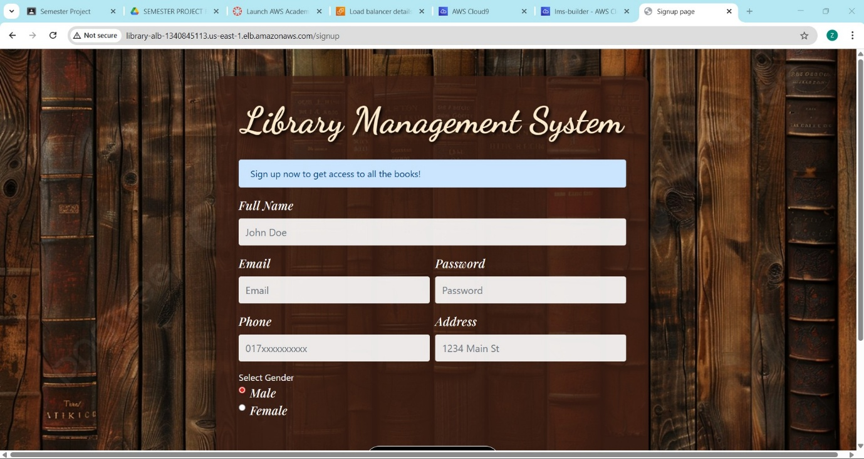

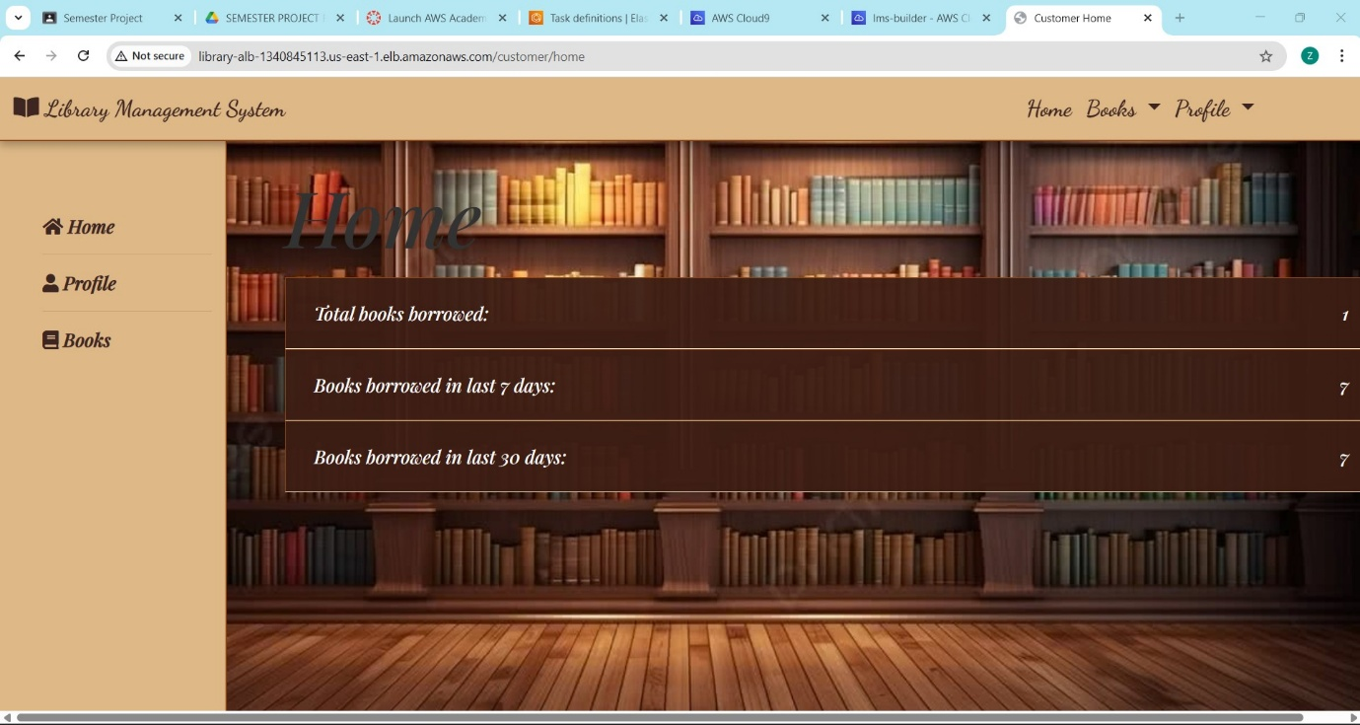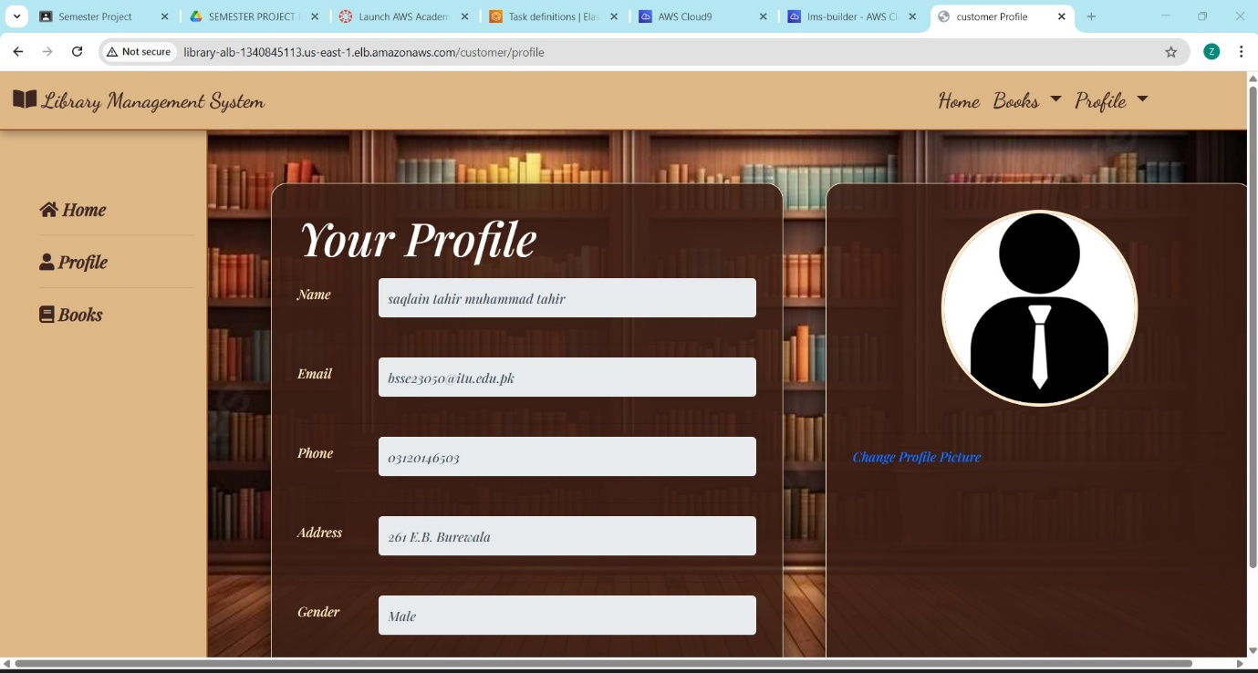

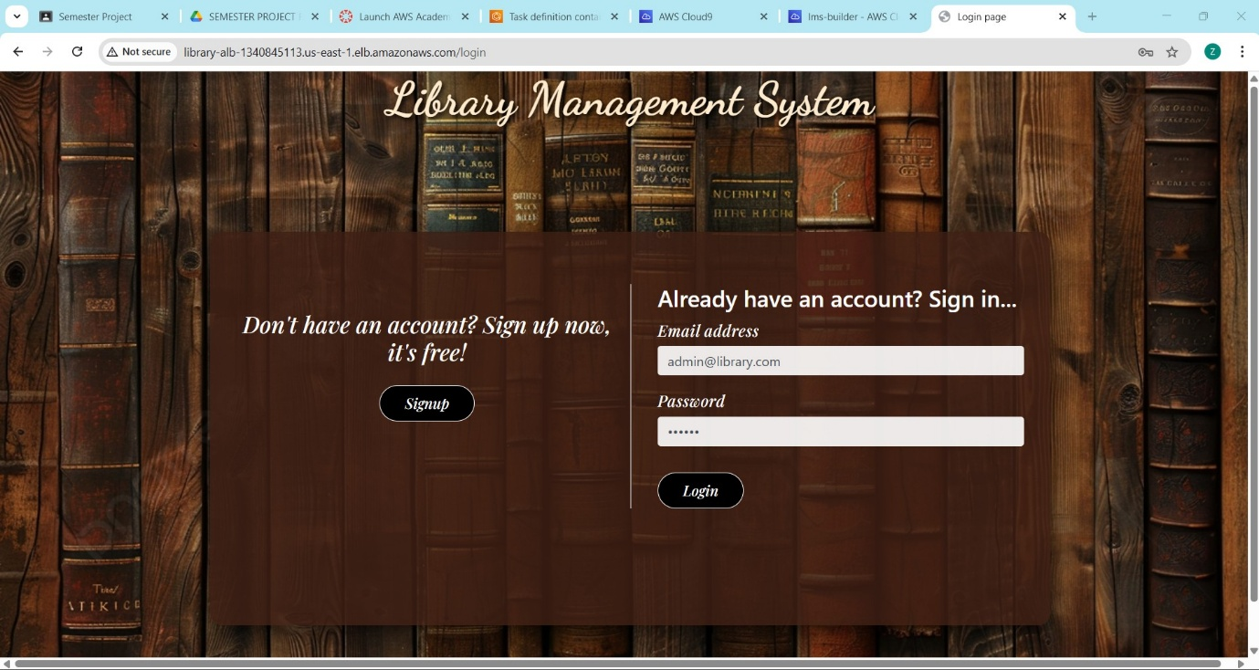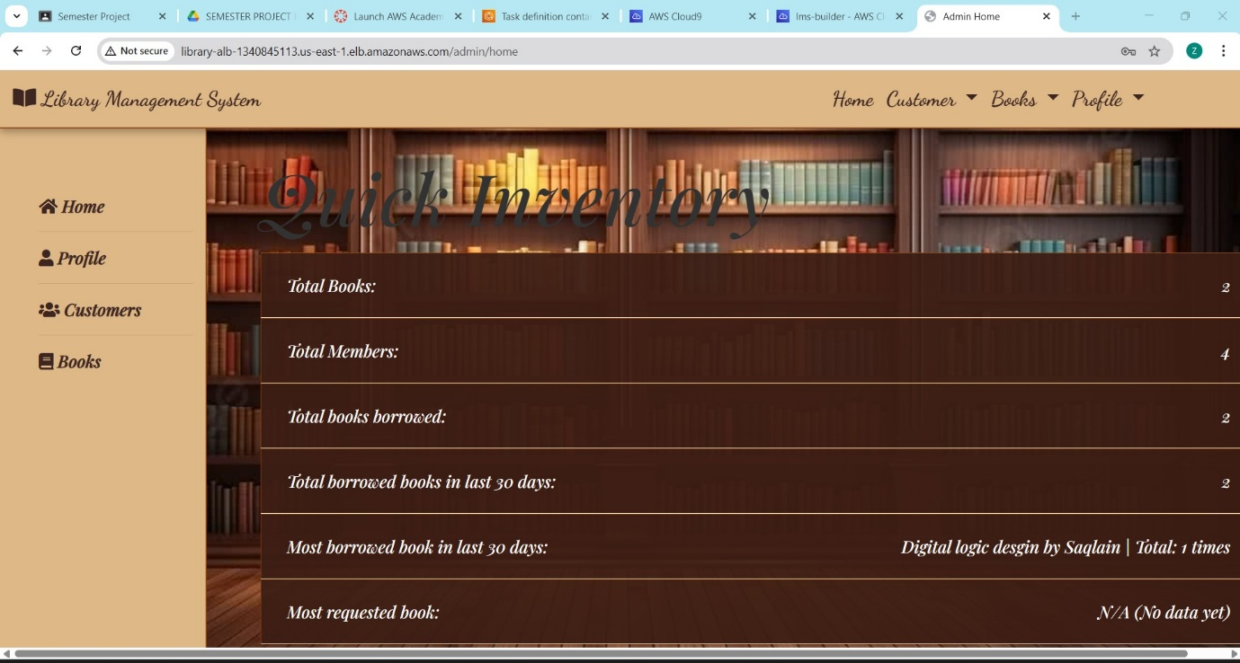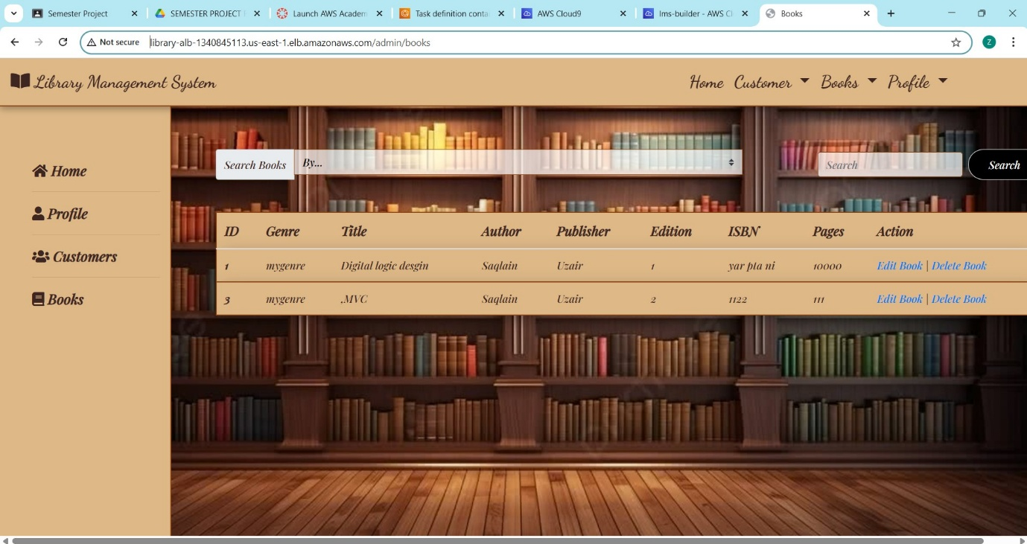

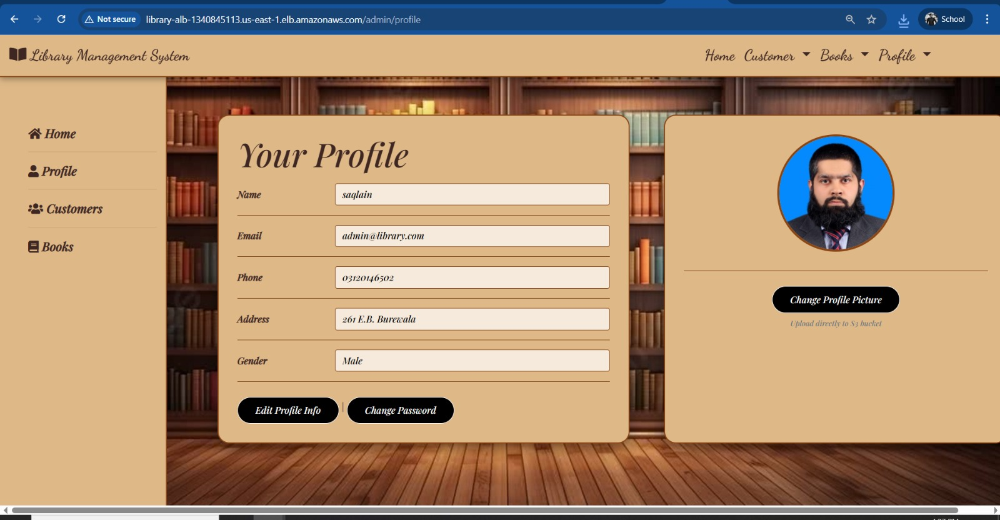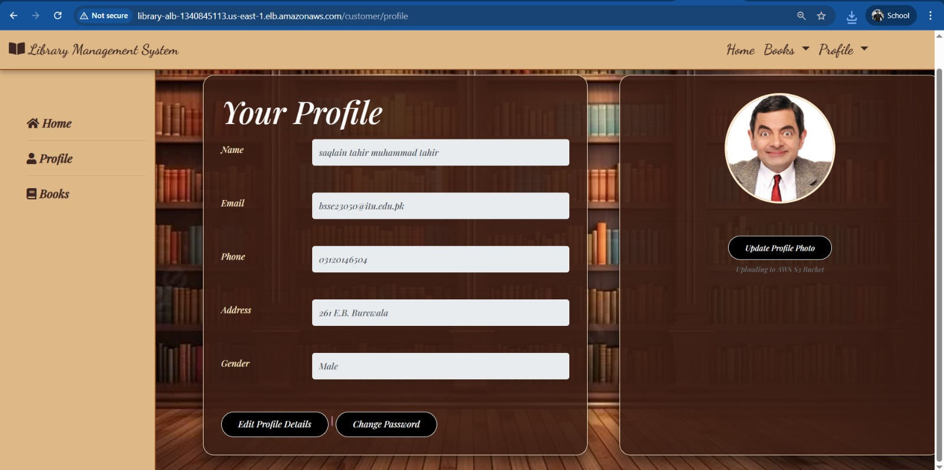
Figure 37-45: Frontend

PHASE 10: MONITORING & OBSERVABILITY

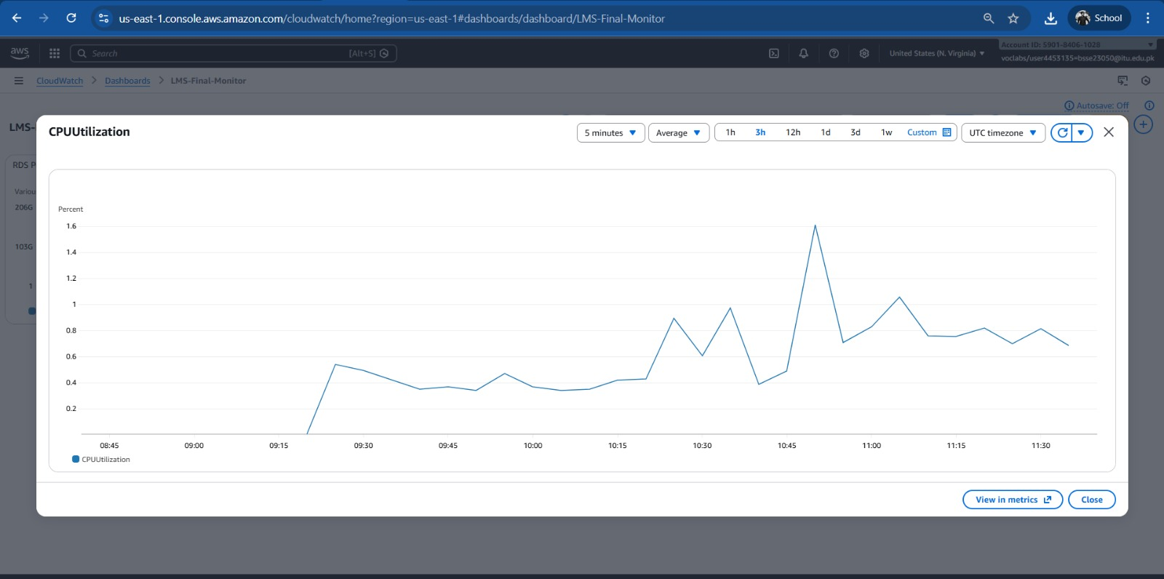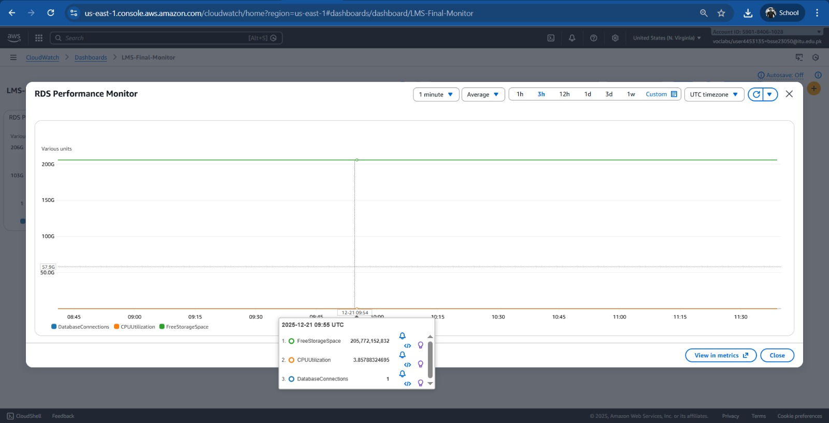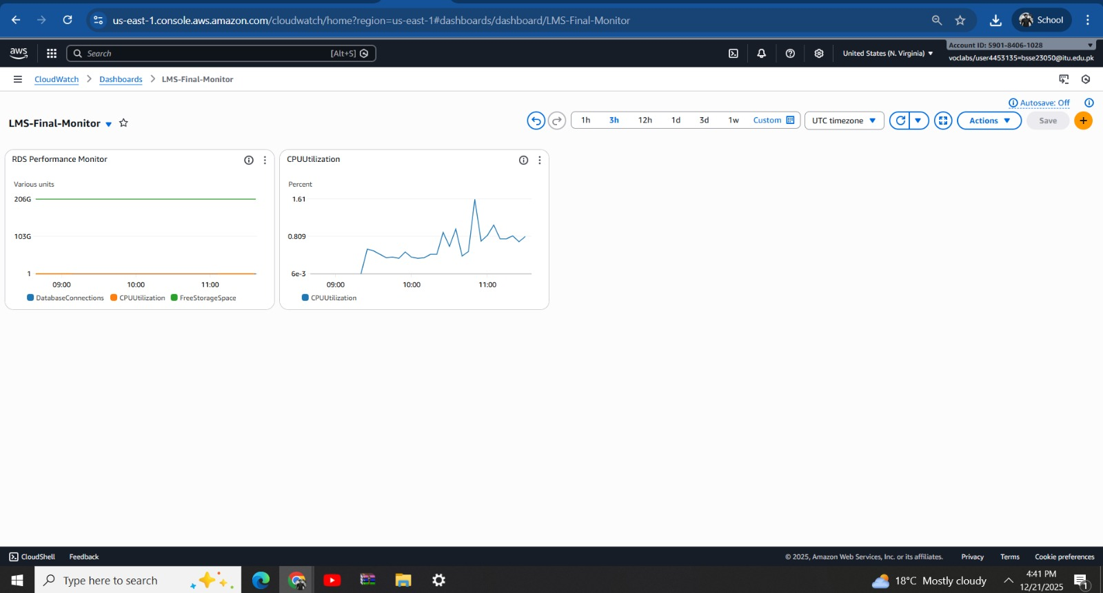
Figure 46-48: CloudWatch RDS Performance and CPU Utilization
- Description: A CloudWatch metrics view displaying the performance of the Amazon RDS database instance. The graph specifically shows CPU Utilization percentage over time, indicating the processing load on the database server.

3. REFERENCES
- Amazon Web Services. (2025). AWS Learner Lab Guide. AWS Academy.
- Amazon Web Services. (n.d.). Amazon ECS Documentation. Retrieved from https://docs.aws.amazon.com/ecs/
- GitHub Repo URL: https://github.com/BSSE-23050/LMS-Project.git
- Amazon Web Services. (2025). Amazon ECS Developer Guide. AWS Documentation.
- Docker Inc. (2024). Containerizing Python Applications. Docker Docs.
- Grinberg, M. (2018). Flask Web Development. O'Reilly Media.
- AWS Academy. (2024). Learner Lab Environment & Troubleshooting Guide.

